Урок 3. Пинг-понг

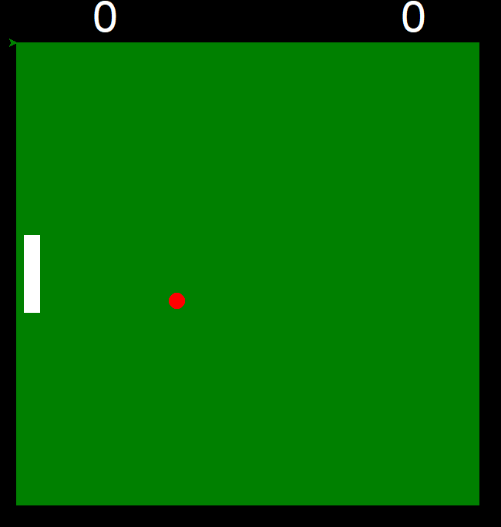import turtle

from random import randint, choice

window = turtle.Screen()

window.bgcolor('black')

window.setup(width=1.0, height=1.0)

border = turtle.Turtle()

border.color('green')

border.speed(5)

border.begin_fill()

border.goto(-300, 300);

border.goto(300, 300)

border.goto(300, -300);

border.goto(-300, -300);

border.goto(-300, 300)

border.end_fill()

rocket_a = turtle.Turtle()

rocket_a.color('white')

rocket_a.shape('square')

rocket_a.shapesize(5, 1)

rocket_a.up()

rocket_a.goto(-280, 0)

rocket_a.penup()

def вверх():

x, y = rocket_a.pos()

if y > 240:

y = 240

rocket_a.goto(x, y + 10)

def вниз():

y = rocket_a.ycor()

if y < -240:

y = -240

rocket_a.sety(y - 10)

window.listen()

window.onkeypress(вверх, 'w')

window.onkeypress(вниз, 's')

# window.onkeypress(move_up_b, "Up")

# window.onkeypress(move_down_b, "Down")

ball = turtle.Turtle()

ball.shape('circle')

ball.color('red')

ball.up()

dx, dy = -4, 5

FONT = ("Arial", 44)

score_a = 0

s1 = turtle.Turtle(visible=False)

s1.color('white')

s1.penup()

s1.setposition(-200, 300)

s1.write(score_a, font=FONT)

score_b = 0

s2 = turtle.Turtle(visible=False)

s2.color('white')

s2.penup()

s2.setposition(200, 300)

s2.write(score_a, font=FONT)

while True:

window.update()

x, y = ball.pos()

x1, y1 = rocket_a.pos()

if x >= 300 or x <= -300:

dx = - dx

if y >= 300 or y <= -300:

dy = - dy

ball.goto(x + dx, y + dy)

# score_a += 1

# s1.clear()

# s1.write(score_a, font=FONT)

if y1 + 50 >= y >= y1 - 50 and x1 - 10 <= x <= x1 + 5:

dx = - dx

dy = - dy

window.mainloop()